2020 C&O 100 Course Guide
Revised Maps……………………………………………………………………………1
Aid Station Mileage Sheet……………………………………………………………...2
Detailed Course Description……………………………………………………………4
Miscellaneous Changes………………………………………………………………...6

2020 Map – C&O Canal is green line
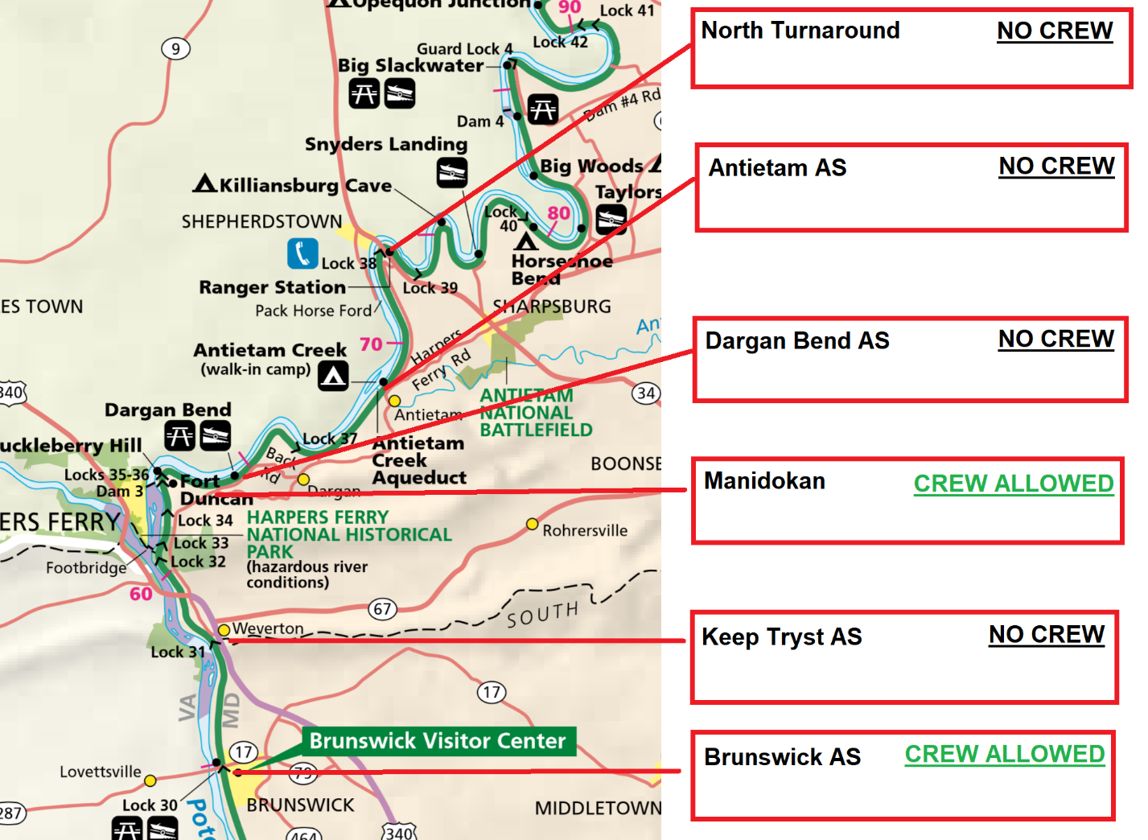
DROP BAGS
DROP BAGS
DROP BAGS
2020 C&O Canal 100 course map with the location of each aid station along the course. The canal is depicted in green along the Potomac River (light blue).

Aid Station Mileage Sheet
Start Time | 7.00
* indicates Saturday |  |  | Front of the Pack | 30 hour even splits | Cutoffs
‡ indicates Sunday | Average Pace | ---------- | 8.00 | 18.00
Aid Station | MILE | Section Distance (miles) | Aid Station Arrival Time | Aid Station Arrival Time
Manidokan- Start | 0
Dargan Bend | 1.4 | 1.4 | 7:11* | 7:25*
Antietam Campground | 6.3 | 4.9 | 7:53* | 8:53*
North Turnaround | 10.1 | 3.8 | 8:26* | 10:01*
Antietam Campground | 13.9 | 3.8 | 8:58* | 11:10*
Dargan Bend | 18.8 | 4.9 | 9:40* | 12:38*
Keep Tryst Rd. | 25.7 | 6.9 | 10:39* | 14:42*
Brunswick | 28.8 | 3.1 | 11:06* | 15:38*
Keep Tryst Rd. | 31.9 | 3.1 | 11:32* | 16:34*
Manidokan | 38.4 | 6.5 | 12:28* | 18:31*
Dargan Bend | 39.8 | 1.4 | 12:36* | 18:56*
Antietam Campground | 44.7 | 4.9 | 13:22* | 20:24*
Dargan Bend | 49.6 | 4.9 | 14:04* | 21:52*
Keep Tryst | 56.5 | 6.9 | 15:03* | 23:57*
Brunswick | 59.6 | 3.1 | 15:29* | 00:52‡
Keep Tryst | 62.7 | 3.1 | 15:56* | 01:48‡
Manidokan | 69.2 | 6.5 | 16:51* | 03:45‡ | 03:45‡
Dargan Bend | 70.6 | 1.4 | 17:03* | 04:10‡
Antietam Campground | 75.5 | 4.9 | 17:45* | 05:39‡
Dargan Bend | 80.4 | 4.9 | 18:27* | 07:07‡ | 06:45‡
Keep Tryst Rd. | 87.3 | 6.9 | 19:26* | 09:11‡
Brunswick | 90.4 | 3.1 | 19:52* | 10:07‡ | 09:45‡
Keep Tryst Rd. | 93.5 | 3.1 | 20:19* | 11:03‡
Manidokan | 100.0 | 6.5 | 21:15* | 13:00‡ | 13:00‡
Paces of estimated front of the pace and back of the pack runners.

Detailed Course Description
Loop 1
Starting from Manidokan runners will proceed around the grass field loop at Manidokan. After completing the field loop proceed down the trail to the C&O Canal. At the C&O canal runner will turn right and run upstream towards Cumberland, MD. Shortly after reaching the canal you will pass Dargan Bend Aid Station. You do not need to stop at this aid station but they will have a place to drop off gloves, or other light garments you might have wanted to start with but do no need once you are warmed up. After running upstream on the C&O Canal for a cumulative total of 6.3 miles you will come to Antietam Campground AS. From Antietam AS you will do an out and back to the North Turnaround (no aid, check in only) with a round trip distance of 7.6 miles before getting back to Antietam AS. Following the canal downstream now you will pass Dargan Bend, Keep Tryst, and Brunswick aid stations (see Table 1 for mileages). At Brunswick AS you will turn around and head back upstream towards Manidokan while passing Keep Tryst. Once you have followed the single-track trail up to Manidokan you will have completed one loop at mile 38.4.
Loops 2 & 3
The second and third loops will follow the first two except you will not do the out and back section to the North Turnaround (instead turning to run downstream at Antietam AS). The second time you come through Brunswick AS (mile 59.6) you may pick up a pacer. You may have one pacer at a time for the remainder of the race. See section below on Misc. changes for more details. At the end of your third loop you will return to Manidokan and finish the race (mile 100.0)!

Miscellaneous Changes
Due to these course changes several logistical items will change for the 2019 race.
Pacers & Crews
The second time you come through Brunswick AS (mile 59.6) you may pick up a pacer. You may have one pacer at a time for the remainder of the race. Crews may still drop off pacers to wait for runners at an aid station after mile 59.6 however this does not impact the locations for crew accessibility on the course. Crews will still only be permitted at Brunswick (parking in the MARC lot only) and Manidokan. This means crews will be able to see runners at Brunswick three times during the race and Manidokan twice (plus the finish). As in the past crews attempting to aid runners at aid stations outside of Brunswick and Manidokan will lead to the disqualification of their runner. This rule is imposed by the National Park Service to limit the impact of the race on other canal users.
Drop Bags
There will only be two drop bags in 2019, one at Brunswick and one at Manidokan. The Brunswick drop bag will need to conform to the dimensions of 6″x8″x16″. There are no limits for the dimensions of the Manidokan drop bag.

Cutoff Times
The overall race cutoff remains 30 hours for the 2019 race, however intermediate cutoffs (see Table 1) have been adjusted backwards to allow more cushion for runners to reach the finish line than they have been in the past.

